**Chapter 4 Lab Work**

**Name: Neelima Marepalli**

**Q.1) Implement a Fahrenheit function that returns the Fahrenheit equivalent of a Celsius temperature. Use the following formula:**

**F = (9/5) * C + 32**

**Use this function to print a chart showing the Fahrenheit equivalents of the Celsius temperatures in the range from 1-100. Print the results in a neat tabular form with one digit of precision.**

**Source code:**

def celsius_to_fahrenheit(celsius):

fahrenheit = (9/5) * celsius + 32

return fahrenheit

# Print chart

print("Celsius\tFahrenheit")

for celsius in range(1, 101):

fahrenheit = celsius_to_fahrenheit(celsius)

print(f"{celsius}\t{fahrenheit:.1f}")

**Output:**

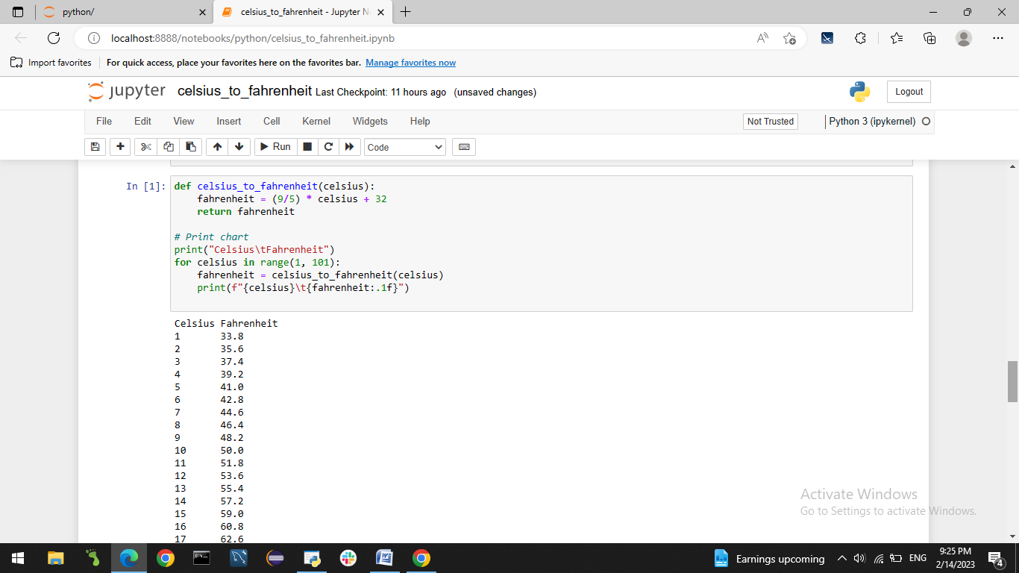

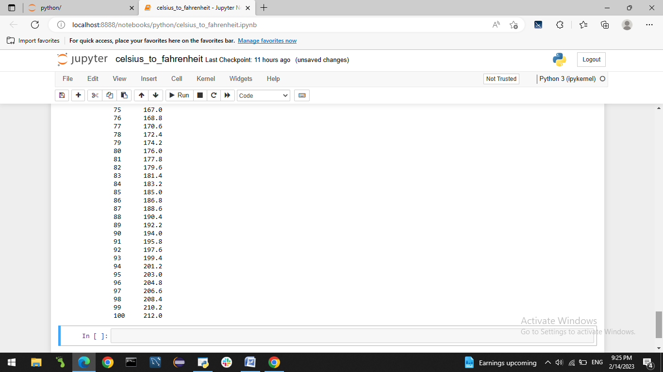

**Q.2) Create a number that plays a guess the number game. Use a random number generator that chooses a number between 1 and 1000. It should not be revealed to the user until they guess the number correctly. It should prompt the user to input a number between 1 and 1000. If the guess is wrong, it should either let them know if the guess was too high or too low along with try again. It should congratulate them once they guess correctly, how many guesses it took, and ask them to play again.**

**Source code:**

import random

def guess_number():

# Generate random number between 1 and 1000

number = random.randint(1, 1000)

# Initialize variables

guess = 0

num_guesses = 0

while guess != number:

# Prompt user to guess a number

guess = int(input("Guess a number between 1 and 1000: "))

# Check if guess is too high or too low

if guess < number:

print("Too low. Try again.")

elif guess > number:

print("Too high. Try again.")

# Increment number of guesses

num_guesses += 1

# Congratulate user and display number of guesses

print(f"Congratulations! You guessed the number in {num_guesses} tries.")

# Ask if user wants to play again

play_again = input("Do you want to play again? (y/n) ")

if play_again.lower() == "y":

guess_number()

# Start the game

guess_number()

**Output:**

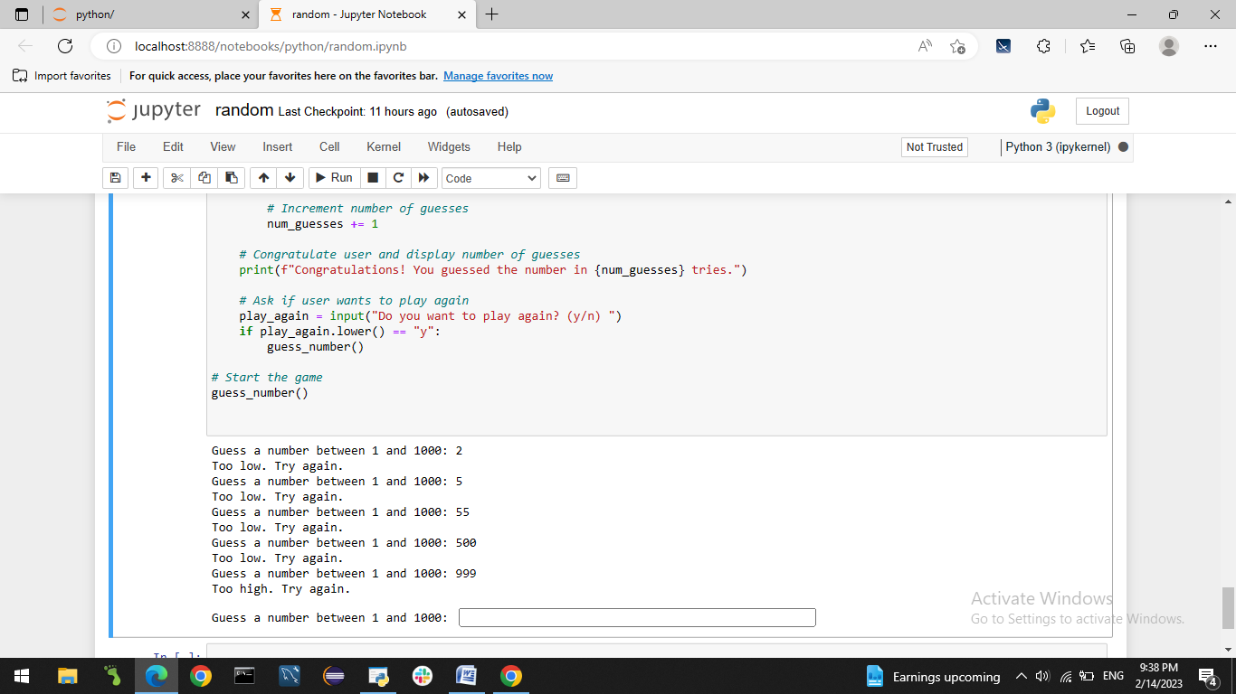

**Q.3) Create a script that helps a student learn multiplication. Create a function that randomly generates two single digit integers. Use the function’s result in your script to prompt the user a question such as “How much is 6 times 7?”. If the answer is correct, it should say “Very good!” and ask another multiplication question if the user wishes to do another question. If it is incorrect, it should ask the user to try again and continue to do so until it is correct. Please demonstrate that both operations work correctly**.

**Source code:**

import random

def generate_numbers():

# Generate two random single digit integers

num1 = random.randint(1, 9)

num2 = random.randint(1, 9)

return num1, num2

def multiplication_quiz():

while True:

# Generate two random numbers and compute their product

num1, num2 = generate_numbers()

product = num1 * num2

# Prompt user to answer the multiplication question

answer = int(input(f"How much is {num1} times {num2}? "))

# Check if answer is correct

if answer == product:

print("Very good!")

# Ask if user wants to do another question

play_again = input("Do you want to do another question? (y/n) ")

if play_again.lower() != "y":

break

else:

print("No. Please try again.")

print("Thanks for playing the multiplication quiz!")

# Start the program

multiplication_quiz()

**Output:**

